List of parts included in kit:
9732-348-001 |  | KIT - BOTTOM EXHAUST OUTLET, T-80
ITEM | P/N | DESCRIPTION | QTY
1 | 9810-020-001 | TEE ASSEMBLY - RECIRCULATION | 1
2 | 9109-122-004 | PIPE - DUCT, 6"x17-1/2" | 1
3 | 9109-122-005 | PIPE - DUCT, 6"x23-1/2" | 2
4 | 9142-039-002 | ELBOW - 90 DEGREE AJD, 6" | 1
5 | 9545-008-003 | Screw-hxwshd,10-16x1/2,tek | 16
6 | 8507-500-001 | INSTRUCTIONS - T-80 BOTTOM EXHAUST OUTLET KIT | 1
*this kit also uses (1) 9142-039-002 ELBOW - 90 DEGREE AJD, 6" that is on the dryer from the factory.
Tools and supplies required:
- Drill with 1/8” bit (for drilling out rivets)
- Impact drive or hand drill with 5/16” driver bit (if using self tapping screws to install instead of rivets)
- Roll of foil duct tape

Steps:
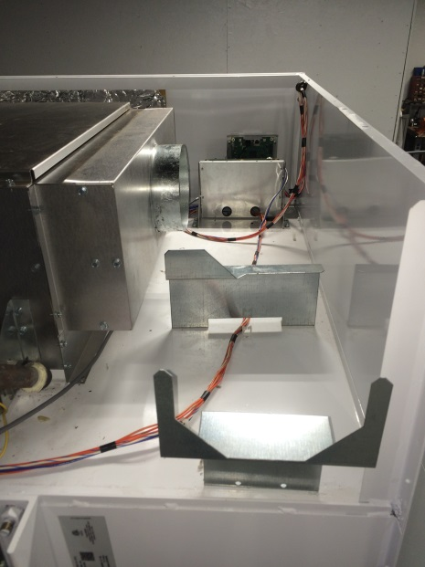
- Remove cabinet top panel
- Remove factory recirculation duct (may require drilling out rivets)

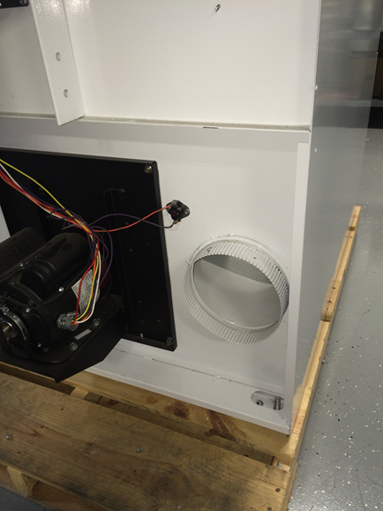
- Remove factory exhaust outlet (may require drilling out rivets).

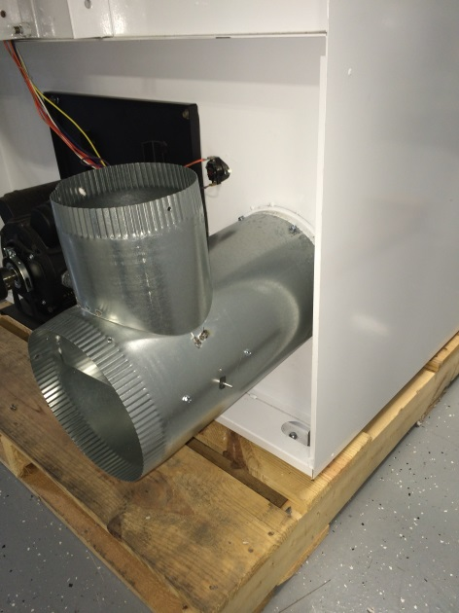

- Install 9810-020-001 TEE ASSEMBLY – RECIRCULATION with (2) provided screw (if allowable by code) into the top.

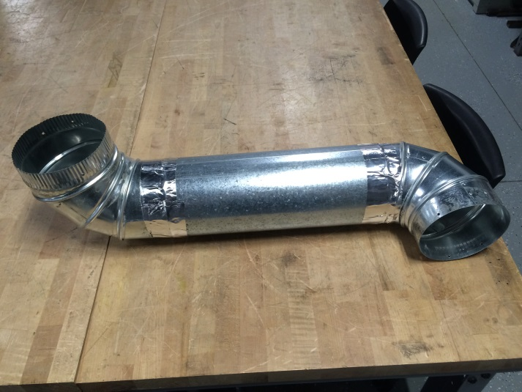
- Pre-assemble upper duct as shown.
(1) 9109-122-004 PIPE – DUCT, 6” x 17-1/2”
(2) 9142-039-002 ELBOW - 90 DEGREE AJD, 6"
(4) 9545-008-003 Screw-hxwshd,10-16x1/2,tek
Assemble elbow outlets 90° from each other. Then secure each joint with (2) screws and foil duct tape.

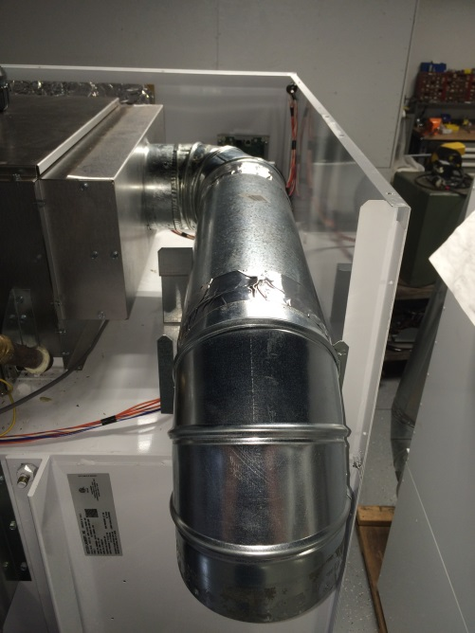

- Assemble duct onto machine as shown with (2) screws through the burner housing recirculation inlet into the recirculation duct.

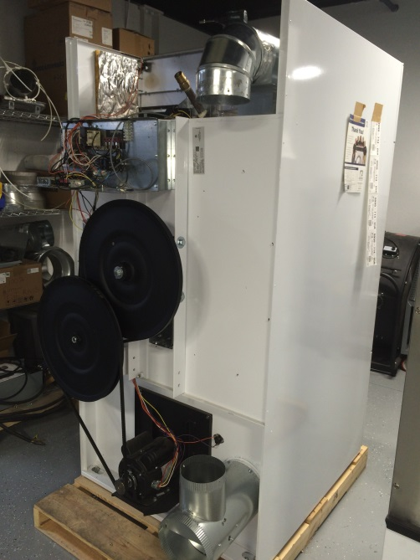

- The machine should look like the picture at this stage.

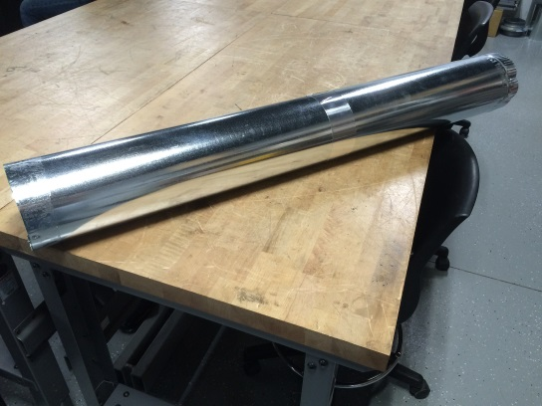
- Pre-assemble duct with (2) screws and foil duct tape.
(2) 9109-122-005 PIPE - DUCT, 6"x23-1/2"

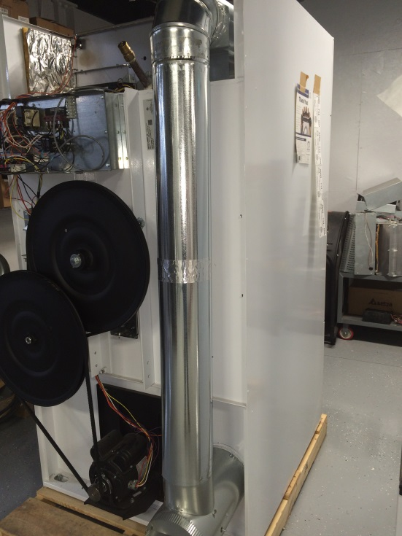
- Install the duct from step 7 as shown and put (2) screws in the upper and lower joints.
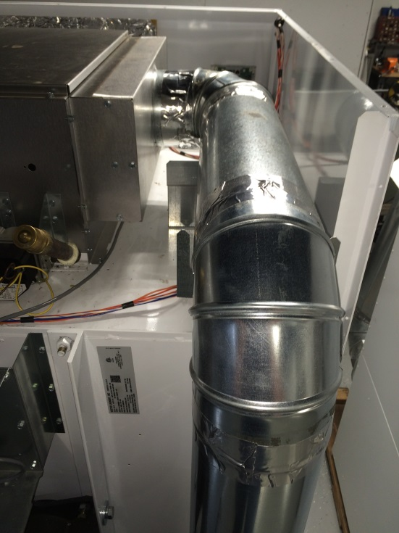
- Finish upper joints with foil duct tape.

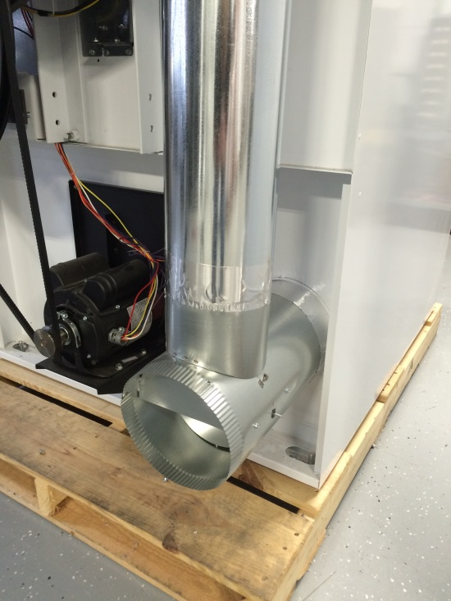
- Finish lower joints with foil duct tape.
- Install top panel.

